**Grammar**

Language description/definition Mechanism – (V,T,S,P)

V- finite set of variables

T – finite set of terminal symbols

S – finite set of starting variables

P – finite set of productions

V & T are non-empty and disjoint

S belongs to V

**Production**

Consists of an LHS and RHS

**LHS = {V U T}^+**

**RHS = {V U T}\***

Example:

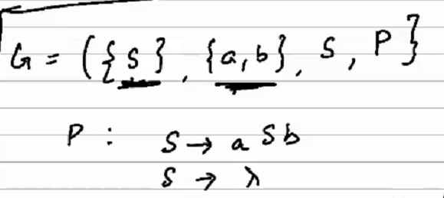

Let G = (V,T,S,P) be a grammar. Then the set

**L(G) = {w belongs to T*: S* => w}** is the language defined by the grammar G.

If w belongs to L(G) then the sequence

S => w1 => w2 … => wn => w is the derivation of the sentence w.

The string w1w2…wn which contains (variable S terminal) is called **sentential form of the derivation**

Example:

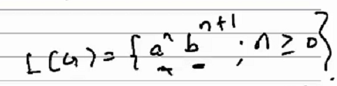

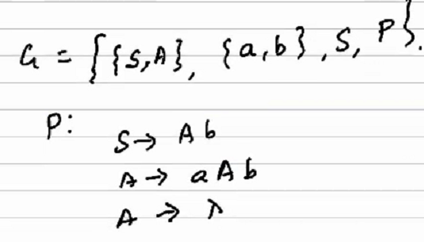

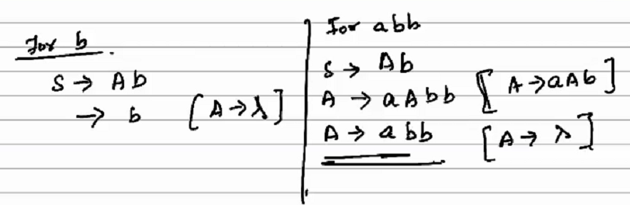

**Automaton**

An abstract model of a digital computer

It has an input file, a control unit and storage. The control unit can be described as a state transition. It reads the input and moves from one state to another. It can also use the storage to store and retrieve values as it moves b/w states. The transition is defined by a transition function.

Eg:

Acceptor – produces yes/no output to show whether input is acceptable or not.

Transducer – can write to a tape to produce a string of symbols as output.

**Configuration** is the specific state of the control unit, input file as well as the temporary storage.

Transition from one state to another is called a “move”.

Types of automata:

1) Deterministic – based on the current state, input symbol and the temp storage, if the next state is exactly predictable, it is a deterministic automata. There is a transition from one state to exactly 1 other state.

2) Non-deterministic – next state cannot be determined or predicted based on current configuration. Transition from one state to multiple other states.